Question: Seeking Some Instructional Magic?

Topic: R546 Instructional Strategies for Thinking, Collaboration, and Motivation
Enroll: Section 8928, Room 2275 IU Bloomington. R546 Syllabus; Free Book: http://tec-variety.com/
Dates and Times: Eight Weeks: August 26 to October 14, 4:00 pm to 9:45 pm

Dear Future Instructional Magicians and Wizards: In this course, you will learn about the magic of creativity, critical thinking, motivation, collaboration, and technology integration. Hundreds of enchanting instructional strategies will be personally demonstrated and experienced. You are guaranteed to learn an endless array of pedagogical magic tricks and incantations. Send your magnetic questions to cjbonk@IU.edu.

Instructor: Curt Bonk, IST Professor. TA: Dilnoza Kadirova, IST Doctoral student, dkadirov@iu.edu

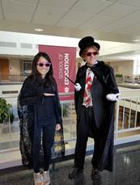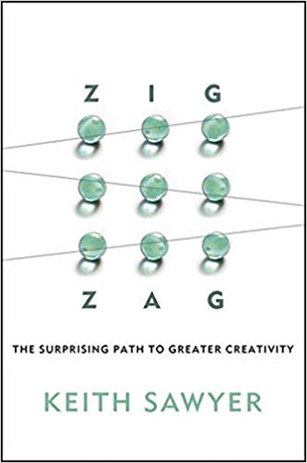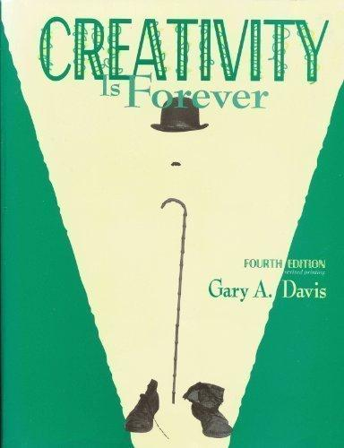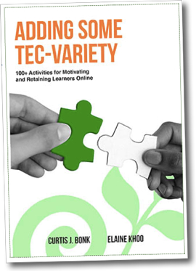

10 Reasons why you might enroll in R546:
- The Relevancy and Impact: The course addresses all educational sectors—K-12, higher ed, corporate, military, government, informal, nontraditional, etc.
- The Exposure to Best Practices: The course has 5 modules filled with best instructional strategies and practices on motivation, creativity, critical thinking, collab learning, and technology integration.
- The Career Benefits (i.e., Want to learn how to teach?): Walk away with dozens of new instructional strategies and ideas as well as a plan on how and where they might implement them.
- The Reusable Resources: Most handouts and activities are reusable in any educational sector.
- The Free Stuff: The free packet of course handouts is offered based on over a quarter century of teaching this course. Free book with 100+ activities: http://tec-variety.com/ (in English or Chinese).
- The Easy to Understand Structure: Simple: 2 tasks are due at midterm and 2 tasks at the end.
- The Sense of Control and Self-Directedness: All readings are student self-selected. No required books or required articles. Students select the books and articles that interest them. I loan books.
- The History: This course has a nearly 30 years history in different format. As a result, there are hundreds of pedagogical ideas, handouts, activities, and alumni of the course.
- The Atmosphere—Monday night: The course is casual on Monday nights; the building is ours!
- The Food: Someone different will bring food each week.
==========================================================
Curtis J. Bonk, Professor, IST Dept, IU Bloomington, Mobile: (812) 322-curt (2878); E-mail: CJBonk@indiana.edu

Curtis J. Bonk is Professor of Instructional Systems Technology at Indiana University since 1992 and adjunct in the School of Informatics. He is a passionate and energetic speaker, writer, educational psychologist, instructional technologist, and entrepreneur as well as a former CPA and corporate controller. He has given hundreds of keynote talks in countries around the world and is an author/editor of a dozen books and over 111 journal articles and over 50 book chapters. Homepage: http://curtbonk.com/

