Curtis J. Bonk, Indiana University, School of Education
Instructional Systems Technology (IST) Department
Long Bio

Long Bio:
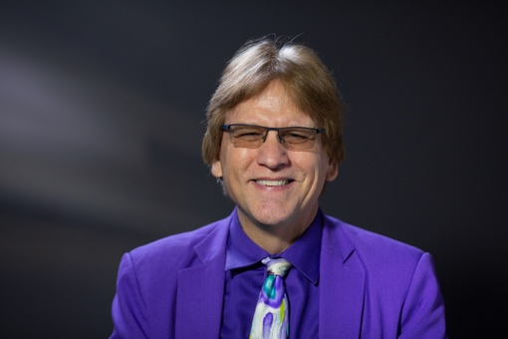
Curtis J. Bonk is Professor in the School of Education at Indiana University (IU) teaching psychology and technology courses and Adjunct in the School of Informatics at IU. He is a former software entrepreneur, certified public accountant, corporate controller, and educational psychologist who presently is an educational technologist, award-winning writer, highly published researcher, statewide and national awardee in innovative teaching with technology, and internationally acclaimed presenter. In 2020, he was awarded the IU President’s Award for Excellence in Teaching and Learning Technology — and in 2021, received the David H. Jonassen Excellence in Research Award. In April 2022, the American Educational Research Association named him a 2022 AERA Fellow for his exceptional contributions to, and excellence in, education research and the following week he was honored with the International Engagement award from the IU School of Education. Curt is the author of nearly 400 publications and has many widely used technology and learning related books, including Transformative Teaching Around the World, Engaging Online Language Learners, The World Is Open, Empowering Online Learning, The Handbook of Blended Learning, Electronic Collaborators, Adding Some TEC-VARIETY, which is free as an e-book (http://tec-variety.com/), and MOOCs and Open Education Around the World as well as MOOCs and Open Education in the Global South (www.moocsbook.com/). Across his career, Curt Bonk has given over to 1,800 presentations around the globe related to online teaching and learning, including over 300 keynote and plenary talks in places like Bangkok, Thailand, Melbourne, Sydney, Shanghai, Hong Kong, Singapore, Beijing, Toronto, Abu Dhabi, Riyadh, Madrid, London, Manila, Seoul, Tel Aviv, Edinburgh, Dublin, Coimbra, Tampere, Barcelona, and Arequipa, Peru. He co-hosts the weekly award-winning podcast show, Silver Lining for Learning (https://silverliningforlearning.org/). He can be contacted at cjbonk@indiana.edu and his homepage is http://curtbonk.com/.

Curtis J. Bonk received his master’s and Ph.D. from the University of Wisconsin in educational psychology and his BA in accounting. He is now Professor in the School of Education at Indiana University (IU) teaching psychology and technology courses and Adjunct in the School of Informatics at IU. He is a former software entrepreneur, certified public accountant, corporate controller, and educational psychologist who presently is an educational technologist, award-winning writer, highly published researcher, statewide and national awardee in innovative teaching with technology, and internationally acclaimed presenter. In 2020, he was awarded the IU President’s Award for Excellence in Teaching and Learning Technology — and in 2021, received the David H. Jonassen Excellence in Research Award. In April 2022, the American Educational Research Association named him a 2022 AERA Fellow for his exceptional contributions to, and excellence in, education research and the following week Curt was honored with the International Engagement award from the IU School of Education. Most recently, he and his podcast team at Silver Lining for Learning (SLL) (https://silverliningforlearning.org/) were named the 2022 recipients of the Distinguished Development Award from the Association for Educational Communications and Technology (AECT) and Educational Technology Research and Development (ETR&D). The SLL team also received an Outstanding Digital Learning Artifact Award at AECT in October 2022.

Curt is the author of over 400 publications and has authored or edited 20 widely used technology and learning related books, including the bestseller in 2009/2011, The World Is Open: How Web Technology is Revolutionizing Education. He has had three books published in 2022, including “Transformative Teaching Around the World: Stories of Cultural Impact, Technology Integration, and Innovative Pedagogy” which contains 41 short and emotional stories of transformative educational innovation and change in 22 countries from Curt Bonk’s former students. Other books include Engaging Online Language Learners, Empowering Online Learning, The Handbook of Blended Learning, and Electronic Collaborators. Bonk has also authored two free books on motivating online learners. The first free book was, Adding Some TEC-VARIETY: 100+ Activities for Motivating and Retaining Online Learners (http://tec-variety.com/) which he self-published in 2014. An update to that book came out in 2022 which was published by the Commonwealth of Learning, Motivating and Supporting Online Learners; it is also a free book (http://hdl.handle.net/11599/4481) and there is an associated free course available: https://colcommons.org/welcome/coursedetails/8; https://www.colvee.org/. In addition, during the past decade, he and his colleagues have edited three books on MOOCs and open education, including: MOOCs and Open Education Around the World (2015) as well as MOOCs and Open Education in the Global South (2020) (www.moocsbook.com/).
Across his career, Curt Bonk has given nearly 2,000 presentations around the globe related to online teaching and learning, including over 300 keynote and plenary talks in places like Bangkok, Thailand, Melbourne, Sydney, Shanghai, Hong Kong, Singapore, Beijing, Toronto, Abu Dhabi, Riyadh, Madrid, London, Manila, Seoul, Tel Aviv, Edinburgh, Dublin, Coimbra, Tampere, Barcelona, and Arequipa, Peru. He co-hosts the award-winning weekly podcast show, Silver Lining for Learning (https://silverliningforlearning.org/). In addition to dozens of radio and television appearances, he has also been interviewed for articles and reports from the Wall Street Journal Online, The New York Times, China Daily, The Boston Globe, Education Week, US News and World Reports, Delta Sky Miles Magazine, AARP, The Seoul Economic Daily, The Central Intelligence Agency, the APA Monitor, the Chronicle of Higher Education, the Sydney Morning Herald, and much more. He can be contacted at cjbonk@indiana.edu and his homepage is http://curtbonk.com/. His mobile is 812-322-curt (2878).

