Curtis J. Bonk
Professor, IST, IU School of Education
April 2, 2026

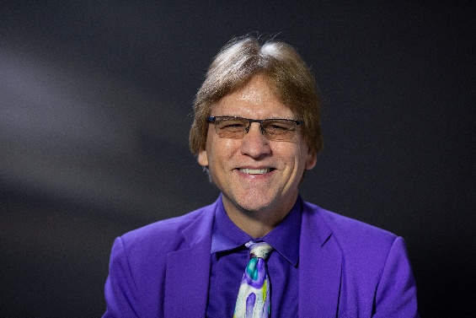

Curtis J. Bonk is Distinguished Professor of Instructional Systems Technology program in the Learning, Design, and Adult Education Department in the School of Education at Indiana University (IU) teaching psychology and technology courses and Adjunct in the IU Luddy School of Informatics, Computing, and Engineering. He is a former software entrepreneur, certified public accountant, corporate controller, and educational psychologist who presently is an educational technologist, award-winning writer, highly published researcher, statewide and national awardee in innovative teaching with technology, and internationally acclaimed presenter. His scholarly interests are self-directed online learning, the use of generative AI for language learning, open education, massive open online courses (MOOCs), e-learning, blended learning, distance education, informal learning, online motivation and collaboration, emerging learning technologies, and AI augmented writing and learning.

Curt is the author of approximately 450 publications (including 20 books and 185 peer reviewed journal articles) and has given close to 2,000 talks on six continents around the world including more than 340 keynote presentations in places like Bangkok, Melbourne, Sydney, Shanghai, Beijing, Hong Kong, Singapore, Beijing, Toronto, Abu Dhabi, Cairo, Riyadh, Madrid, London, Manila, Seoul, Tel Aviv, Edinburgh, Dublin, Coimbra, Tampere, Barcelona, and Arequipa. He has been a visiting scholar/distinguished professor in 11 different countries. His books include Transformative Teaching Around the World (which received an Outstanding Book Award from AECT in 2023); Engaging Online Language Learners; The World Is Open: How Web Technology is Revolutionizing Education; Empowering Online Learning; The Handbook of Blended Learning: Global Perspectives, Local Designs; Electronic Collaborators; Adding Some TEC-VARIETY, which is free as an e-book (http://tec-variety.com/); Motivating and Supporting Online Learners (also free; DOI 10.59668/699); and MOOCs and Open Education Around the World as well as MOOCs and Open Education in the Global South (www.moocsbook.com/).

For many years, he has been listed in the Stanford University list of top 2% of scientists in the world based on publication citations for career as well as for the prior year. In 2020, Curt was awarded the IU President’s Award for Excellence in Teaching and Learning Technology, and, in 2021, he received the David H. Jonassen Excellence in Research Award from AECT. A year later, the American Educational Research Association named him a 2022 AERA Fellow for his exceptional contributions to, and excellence in, education research, and in 2023 AERA recognized him with the Outstanding International Research Collaboration Award. Later in 2023, the US Distance Learning Association honored Curt with a USDLA Excellence in Distance Learning Research Award in Higher Education and the Online Learning Consortium (OLC) made him an OLC Fellow for his “Extraordinary Global Leadership and Contributions to the Field of Online and Blended Learning.” And in 2024, the Association for Educational Communications and Technology (AECT) named Curt as a Fellow and he became Executive Board Chair of the International E-Learn Conference from the Association for Advancement of Computing in Education (AACE) where he is a Fellow as well.

Curt has been on dozens of radio and podcast shows and been interviewed for articles in the Wall Street Journal, NY Times, China Daily, Boston Globe, Education Week, AARP, APA Monitor, Chronicle of Higher Education, Time Higher Education, and Sydney Morning Herald. He has consulted with the CIA, NSA, Microsoft, Cisco, the Army Research Institute, the U.S. Department of Defense, Blackboard, Sun, Saudi Aramco, Contact North, McGraw-Hill Publishing, LG, Samsung, NASA, Intel, Defense Acquisition University, and dozens of school districts, colleges, and universities.

Curt co-hosts the weekly multiple award-winning podcast show, Silver Lining for Learning (https://silverliningforlearning.org/). He can be contacted at cjbonk@iu.edu and his homepage is http://curtbonk.com/.

