This document is a template document that gives the authors of ICER2025 a template to work from. Full papers should be around 4-5 pages including abstract and references.

***(ICER - Title). Title in sentence case. Times New Roman 14 bold: Guidelines for the submissions for the proceedings***

**(Author Name) Author1, Author2**

(Author Details) Department or Center, Institution, email address(s)

**(Author Name) Author3**

(Author Details) Department or Center, Institution, email address(s)

**Abstract**

(ICER - Abstract Text) The abstract should be a maximum of 300 and no less than 200 words. The abstract will also be used on the conference website before the conference.

**(ICER - Heading 1) First level heading in Times New Roman 12 bold**

(Normal) Body of your submission. In brief, this text uses Times New Roman 10 point, left-right aligned, single-spaced. Blank lines before and after headings and paragraphs are sized the same as text lines (Times New Roman 10-point).

The margins for all submissions should be ‘normal’ 2.54 cm all around. Please do not amend the margins to fit your paper onto the maximum number of pages.

**(ICER - Heading 2) Second level heading in Times New Roman 10 bold**

No further spaces are needed after a Heading 2.

[ICER – Block Quote] Use Times New Roman 10 point, left-aligned, single-spaced, indented 1.0 cm left and right, not italicised, without quote marks, one blank line before and after. The right indent may be varied slightly from 1.0 cm to improve the fit. Give the referencing for the quotation in the running text immediately before the quotation or append it to the end of the quotation. In general, very short quotations using only a few words should be given with quote marks in your running text, whilst only longer quotations using a line or more should be formatted as block quotations. (ICER, 2010, p. 10)

This is a bulleted list (List Bulleted)

* Times New Roman 10-point left aligned, single-spaced, no indents except a hanging indent 0.63 cm
* Second bullet item
* Last bullet item

This is an ordered list (List Numbered)

1. Times New Roman 10-point
2. Left-aligned, single-spaced
3. No indents except a hanging indent 0.5 cm (Indentation may be varied slightly to improve the fit.)

(ICER Table Caption) Table 1: A sample table

|  |  |
| --- | --- |
| Location | (ICER - Table) Tables must be placed in their correct, appropriate locations in your running text |
| General | Use Times New Roman 10-point and other body text specifications for all text within a table and its title, though 9-point may be used as required for narrow columns. All tables should have a title with consecutive numbering (e.g., Table 1: Title of the table), bolded, using sentence case, Centerd, and located at the top of the table. For headings within tables use sentence case, with bold and Center optional. |
| Format | Center each table and select appropriate widths for the table and for each column, using percentages. Use of borders for all cells (“All,” with style '1/4 point') is recommended, mainly because borders seem to be helpful for on-screen reading. In columns of numbers, use Center or decimal point alignment. |
| Explanatory text | If your table requires explanatory text that is inappropriate for placing in your running text, place it at the bottom of the table, formatted to the same width as the table. |
| Other features | Cell background colouring or shading may be used but check that greyscale printing (600 dpi) is not impaired and note that when a web version file is created, the Proceedings editors may use a standard background colour for the first row or other elements of a table. |

Make sure you do not allow text to flow too close to the footer - there needs to be some space between text & footer. Use a page break if necessary.

Figures and images must be Centerd too. Make sure that the figure caption is included after the figure or image. They should be numbered 1, 2, 3, … etc., as for example Figure 1.

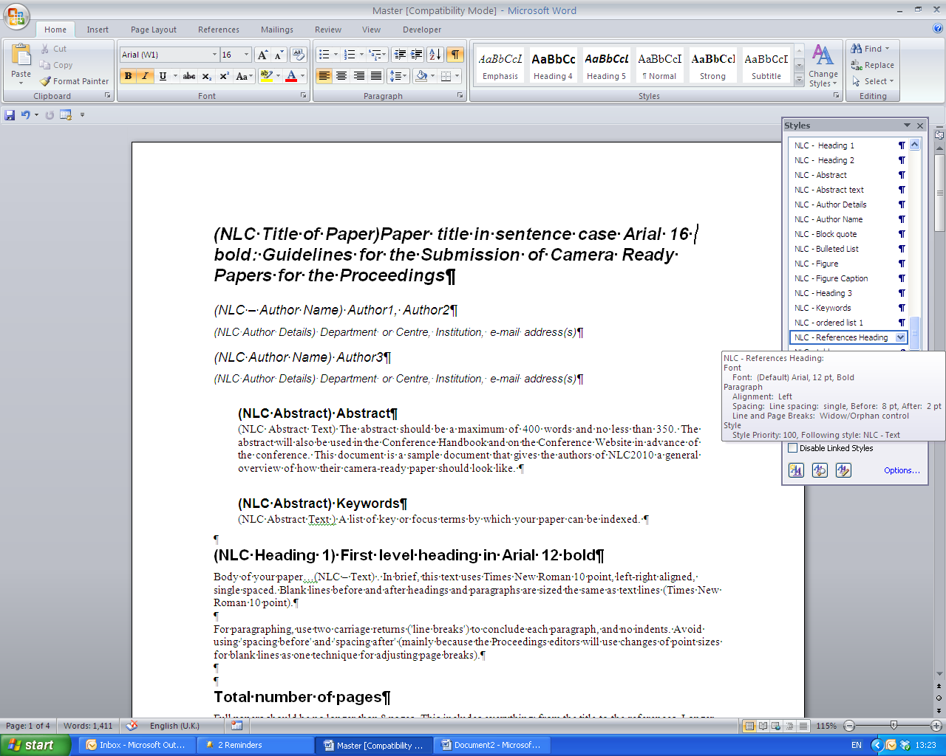

(ICER - Figure Caption) Figure 1: Figure Example

**References**

In your reference list please use the most recent edition of APA. This style prescribes alphabetical order by the first author. Uses Times New Roman 10-point, left-aligned, hanging indent 1cm, no blank lines. The following list provides examples of referencing for the main kinds of publications.

(ICER - References)

Beasley, R.E., & Vila, J.A. (1992). The identification of navigation patterns in a multimedia environment: A case study. *Journal of Educational Multimedia and Hypermedia, 1*(2), 209–222.

Kearsley, G. (2004). *Explorations in learning & instruction: The theory into practice database.* Retrieved June 14, 2004, from <http://www.gwu.edu/~tip/>

O'Shea, T., & Self, J.A. (1983). *Learning and teaching with computers.* Prentice-Hall Inc.

Underwood, J. (1997). Breaking the cycle of ignorance: Information technology and the professional development of teachers. In D. Passey & B. Samways (Eds.), *Information Technology: Supporting change through teacher education* (pp. 155­–158). Chapman & Hall.